Game Design Document

Fill up the Following document

1. Write the title of your project.

FOOTBALL

1. What is the goal of the game?

TO SCORE GOALS

1. Write a brief story of your game?

IN THIS GAME EVERYONE WILL GET 60 SECONDS. IF THE PLAYER SCORES 15 GOALS IN 60 SECONDSTHEN THE PLAYER WINS

1. Which are the playing characters of this game?

* Playing characters are the ones which respond to the user based on the input from the user
* Cars, monkeys, dinos, wizards etc, are the playing characters in the game.

|  |  |  |
| --- | --- | --- |
| Number | Character Name | What can this character do? |
| 1 | PLAYER | SCORING GOAL |
| 2 |  |  |
| 3 |  |  |
| 4 |  |  |
| 5 |  |  |
| 6 |  |  |
| 7 |  |  |
| 8 |  |  |

1. Which are the Non Playing Characters of this game?

* Non Playing characters are the ones which don't have an action or a behaviour when the user interacts with the game.
* Hurdles, stones, bananas, coins, etc are non playing characters in the game.

|  |  |  |
| --- | --- | --- |
| Number | Character Name | What can this character do? |
| 1 | FOOTBALL | PLAYER WILL KICK THIS BALL |
| 2 | GOAL POST | PLAYER HAS TO SCORE GOAL IN THE GOAL POST |
| 3 |  |  |
| 4 |  |  |
| 5 |  |  |
| 6 |  |  |
| 7 |  |  |
| 8 |  |  |

Draw your imagination of this game. What does this game look like?

* Draw the game either on your computer or on paper,
* Add images of scenes of the game to show each of the playing and non-playing characters at least once.

How do you plan to make your game engaging?

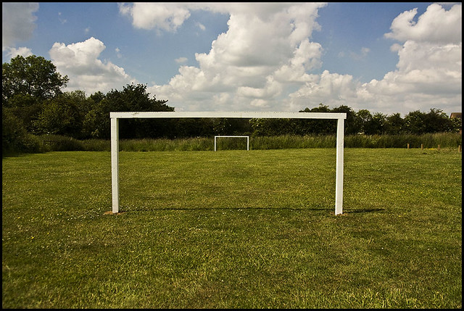

[This Photo](http://qpol.qub.ac.uk/the-backstop-shifting-goalposts-shifting-red-lines/) by Unknown Author is licensed under [CC BY-NC-ND](https://creativecommons.org/licenses/by-nc-nd/3.0/)

There is a goal post and a football and there will be a boy who will get 60 seconds to score 20 goals to win the game

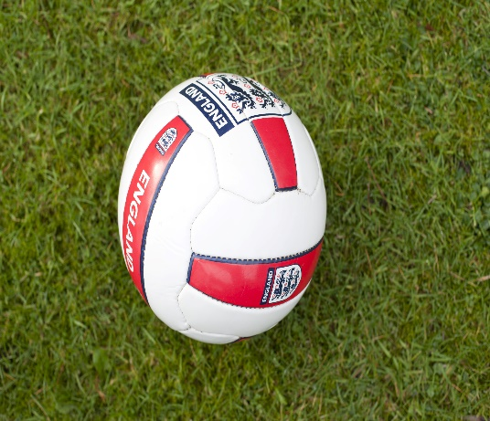

[This Photo](http://www.freeimageslive.co.uk/free_stock_image/football-jpg) by Unknown Author is licensed under [CC BY](https://creativecommons.org/licenses/by/3.0/)